Samba Server

Steps for to build samba server:

- Install required samba packages.
- Make directory with 1777 permission to share.
- Configure samba server.
- Creates samba users.

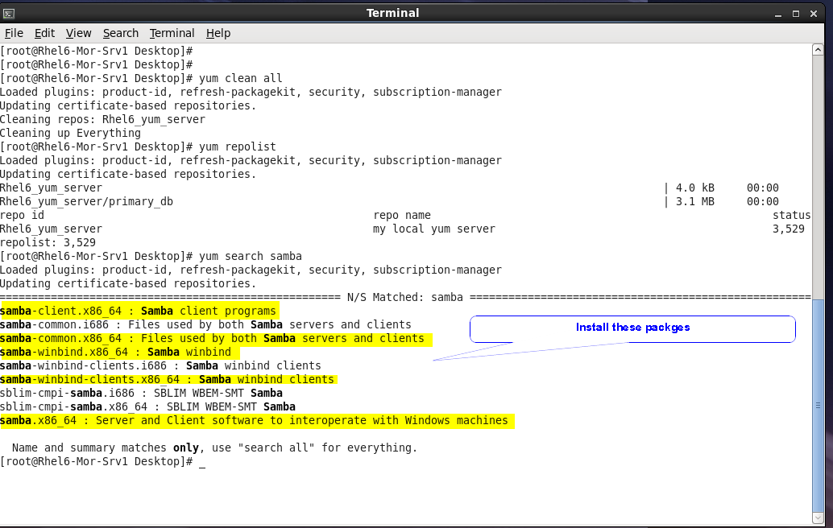

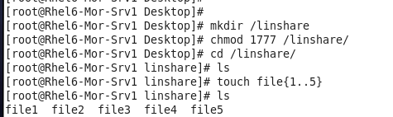

This is the samba server configuration file
/etc/samba/smb.conf

to share with windows network
workgroup = WORKGROUP

uncomment
security = user
passdb backend = tdbsam

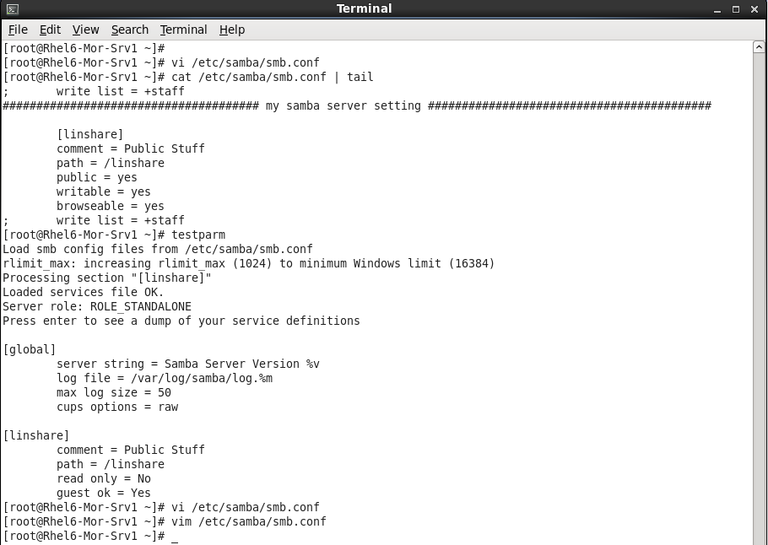

as shown cat of sam.conf

add this block of code in your config file.

Test your samba server with testparm command

disable firewall.
Make selinux permissive.

Check status of smb,nmb and winbind services and turn them on.
Make them persistant.
Test smb server.

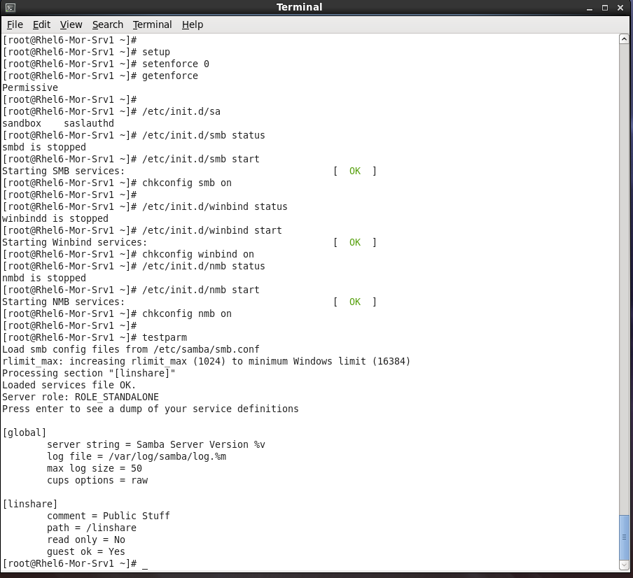

Create two users and convert them in to samba users.

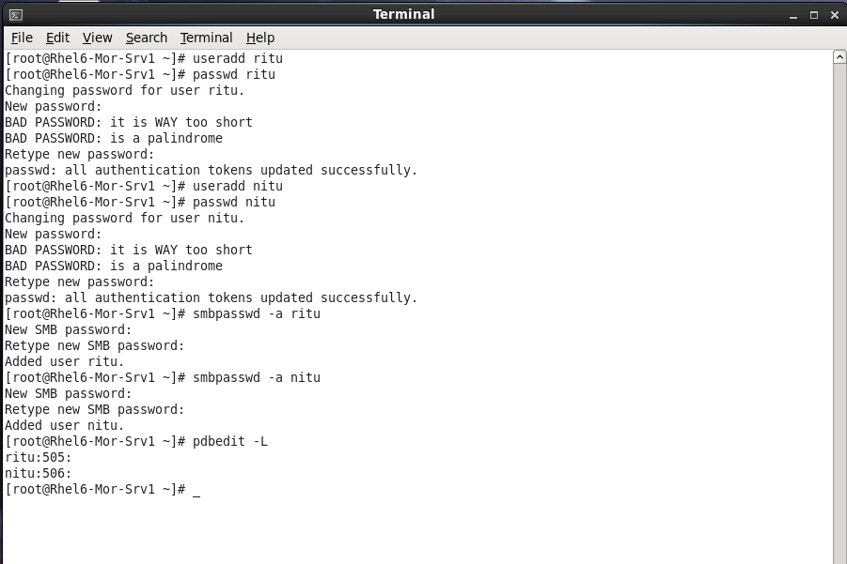

Server side setting done

go to client side

access your server using ip

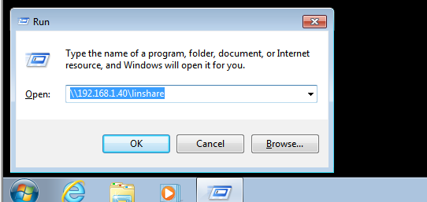

enter your samba user name and pass

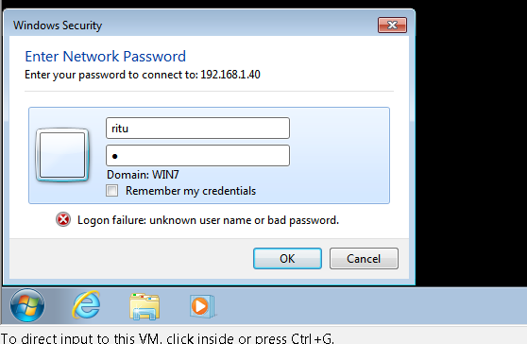

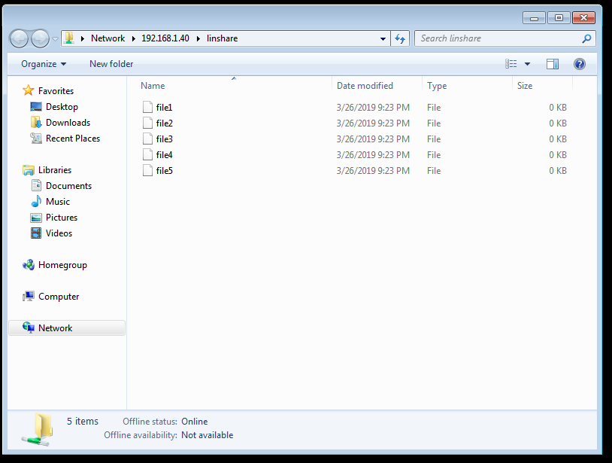

we are connected to samba server and got an access to shared samba directory that is linshare with our files.

Go back to server unable firewall and selinux and write Firewall and Selinux rules to accept traffic even after security is unabled.

